Physics – Factors affecting the severity of crashes

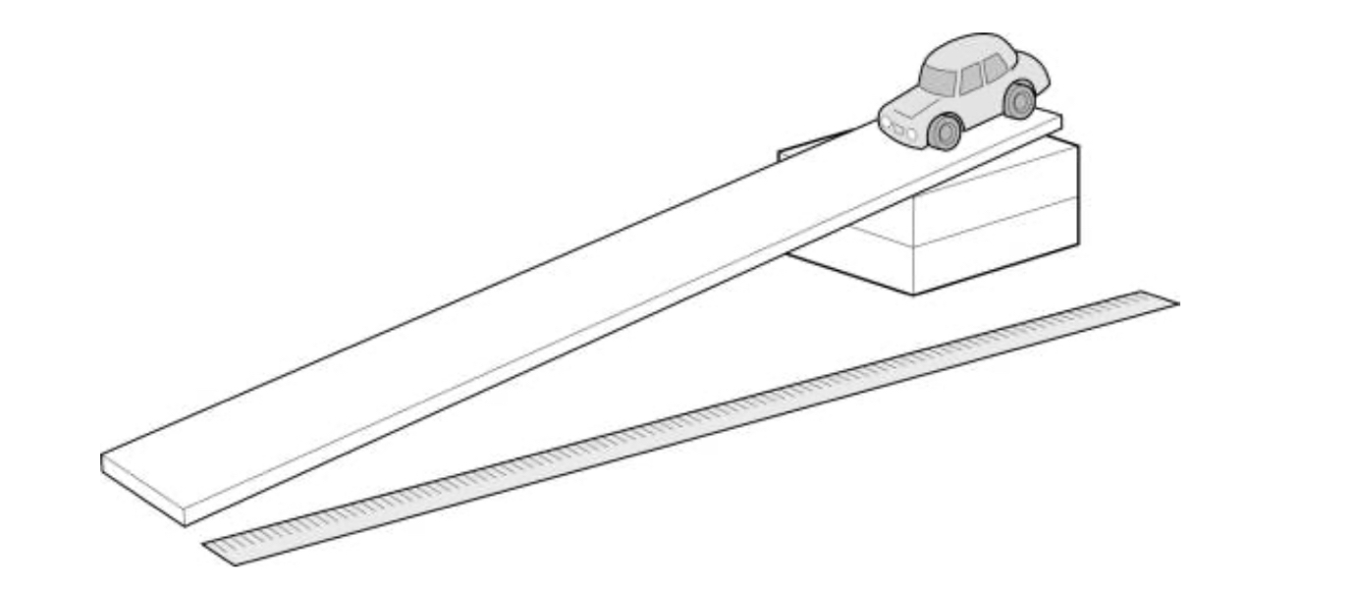

Introduction…………………………………………………………

Purpose…………………………………………………………

Aim………………………………………………………………

Hypothesis ……………………………………………………

Materials and Method………………………………………………

Variables ……………………………………………………….

Materials………………………………………………………

Material set-up…………………………………………………

Method…………………………………………………………

Results………………………………………………………………

Table 1………………………………………………………….

Table 2…………………………………………………………

Discussion ……………………………………………………………

Evaluation…………………………………………………………….

Conclusion …………………………………………………………

Introduction

The purpose of this report is to discuss and investigate how different variables such as mass and friction affects the acceleration of an object on an angled ramp. This investigation looks back to Newton’s second law of motion which covers the relationship between force mass and acceleration which influences the experiment. The aim of this investigation is to determine and understand the relationship between friction and acceleration. It is hypothesised that an accelerating object’s speed will decrease when moving down a surface with friction with an increased mass.

Variables

The independent variable (variable that was changed) in this experiment was the friction caused by the bubble wrap, which was added to the ramp, the objects mass (starting point 80 grams, increased by 20 grams every three trials, finishing at 160 grams). The dependent variable is the speed the object travels down the ramp. The controlled variables was the angle at which the ramp was set and the distance the object travelled.

Method

The method we used for this experiment involved setting up a 1.8 m peace of cardboard and leaned it against a 0.32m high box to form a ramp for our object to move down. We then got a object and added 80 grams of clay to it and used it as the vehicle in this experiment and set it up at the top of the ramp and connected a long narrow peace of paper onto our ‘vehicle’ and connected the paper to a ticking machine which creates a small dot on the paper which indicates to us the amount of time the object took to reach the end of the ramp. We then added 20 grams of clay to the object every three times the ‘vehicle’ went down the ramp. At the end of each trial we counted the first 10 dots marked on the paper (determines the objects initial velocity) and the last 10 dots marked on the tape (determines the objects final velocity) which we then used to find the time taken by the object to go down the ramp. Finally we re-did everything again but with bubble wrap on the ramp to create friction, we then compared the two tables of results.

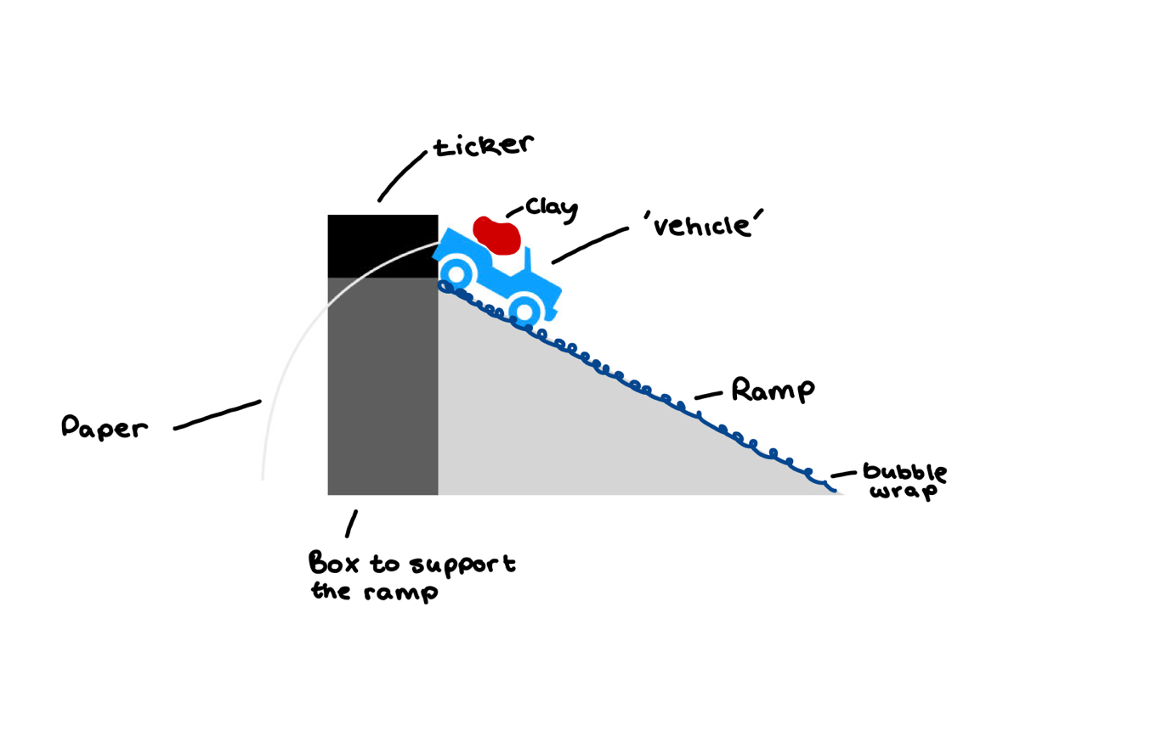

Results

Tables:

No bubble wrap

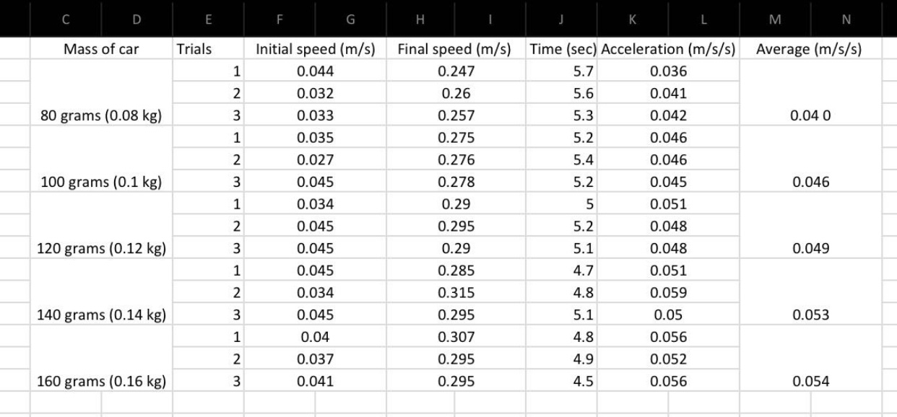

Bubble wrap

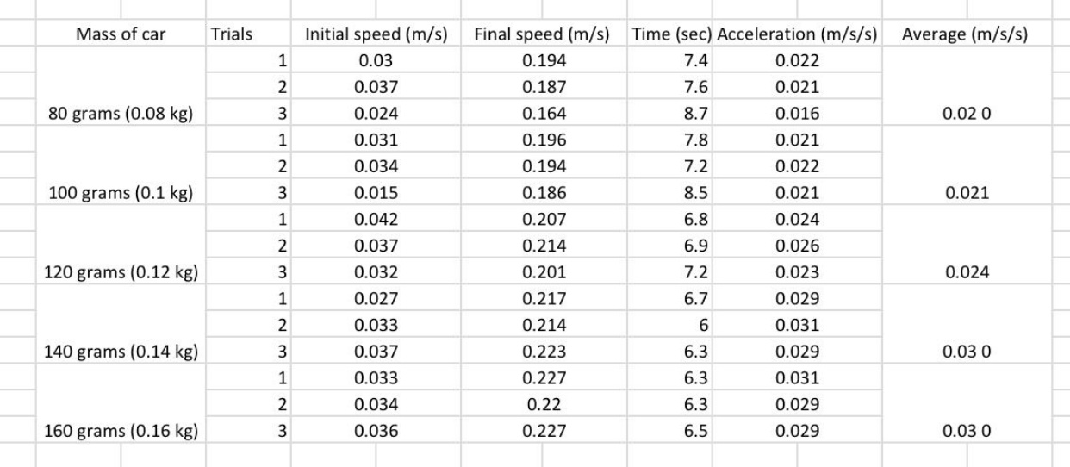

Graph:

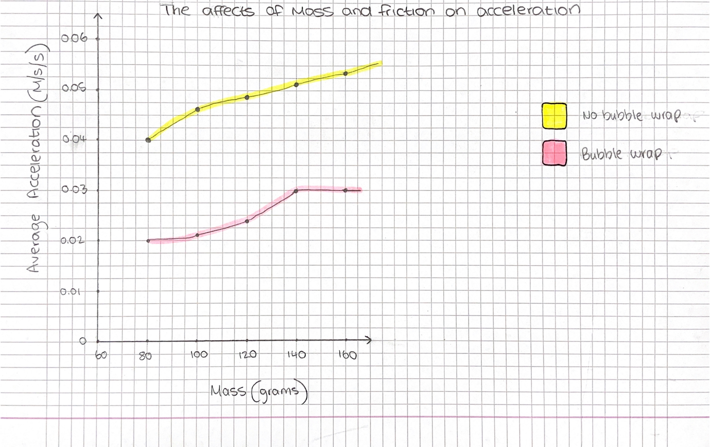

Discussion

Through the comparison of our two tables (friction and non friction) we can clearly see that the acceleration of our ‘vehicle’ drastically decreased when we added friction (bubble wrap) to our ramp. As shown in the tables the averages of the first 3 trials (mass of 80 grams), the non bubble wraps average was 0.040 and in the bubble wrap table the average was 0.020, meaning that the friction slowed down that ‘vehicles’ acceleration by half. On the first table (no bubble wrap) the first three trials with the mass of 80 grams averages was 0.040 and on the last three trials when the mass was increased by 80 grams the average increased to 0.054, meaning the vehicles speed down the ramp increased by 0,014 and on the second table (bubble wrap) the first three trials of 80 grams average was 0.020 and on the last three trials of 160 grams the average was 0.030 meaning the acceleration of the ‘vehicle’ increased by 0.010, this shows that the higher the mass of an object means the higher its acceleration.

Evaluation

The validity of the experiment was maintained through controlling variables such as the angle at which the ramp was set and the distance the object travelled. Each trial was repeated three times before another 20 grams was added to the object. The results where accurate because the outcome for each trial for each mass were similar.

Conclusion

In this experiment we measured the effects of mass and friction on the acceleration of a descending object. In the experiment we concluded that when the mass of an object increased the objects acceleration increases even when friction is added to the surface the object is travelling on.